RANGI RURU PRE-SCHOOL
PARENT HANDBOOK

INDEX

Welcome to Rangi Ruru Pre-school 2
Contact details

The Staff 3-6

Centre Philosophy 7-8

Centre curriculum and Programme 9

Operating hours & 20 Hours ECE 10
20 Hours
Centre Hours
Statutory Holidays and closure over December/January

Starting at Rangi Ruru Pre-school 11-12
What to bring
Arrival procedures
Attendance sign-in

Health and Wellbeing 13
Immunisation register
Vision and Hearing tests
Illness
Accidents
Administering medication
Crisis Management Procedures
Keeping you informed and involved 14-15
Communicating with families
Daily and Weekly Notices
Children’s profile books
Parent Information folder Policies and procedures
Communication and Complaints procedure

Fees and accounts 16-17
Accounts
Childcare subsidy/WINZ
Absences/holiday allowances

Updated 4 September 2017

Welcome to Rangi Ruru Pre-school

Rangi Ruru Pre-school provides care and education for children aged from 2 years to school entry. The Pre-school was founded in 1988.

The centre is situated in a spacious and comfortable re-modelled house. It lies within the Rangi Ruru Girls’ School grounds close to the centre of Christchurch and enjoys many benefits of having close liaison with the school. We have the use of their extensive and attractive gardens and playing field, along with visits to the gymnasium, library, drama suite and science labs.

The convenient centre location enables staff to plan excursions with children in the local and inner city area, which adds an important dimension to the centre’s programme.

Contact Details:
Street address: 46 Rhodes Street, Christchurch, 8014
Postal address: 59 Hewitts Road, Christchurch, 8014
Telephone: +64 3 983-3757
Facsimile: +64 3 983-3710
E mail: preschool@rangiruru.ac.nz
Website: www.rangirurupreschool.nz

The Pre-school Staff

Linda Scanlan
B.TchLn, Dip T (ECE),
Cert Educational Management ECE
Cert Infant and Toddler Mental Health
Currently undertaking Masters of Education
Registered Teacher
Centre Manager

Kia Ora,
I am very privileged to lead the team here at Rangi Ruru Preschool and I am extremely proud of the educational programme, respectful care and strong partnership with children and families, which we have in place.
I have been married for over 20 years to Nick and together we have three beautiful girls, Eloise, Evelyn & Helena.
My comprehensive background in aspects of early childhood education also includes supervisory roles in private and community -based preschools. I have been a tutor & moderator in distance delivery of early childhood teacher qualification courses for the University of Canterbury: Christchurch College of Education. I have also been a Professional Practice visiting tutor, working face to face with early childhood teaching students.

My personal belief is that management and teachers within the early childhood sector must constantly be involved in a process of self-reflection and review to ensure that the programmes they provide are consistent with, and honour our curriculum, Te Whāriki. The provision of high quality education and care for your children can be achieved through successful partnership with teachers/children/parents/whānau and school community.

I look forward to welcoming you and your child into the Rangi family/whanau.

Keri Granger
B.TchLn, Dip T (ECE),
Cert Infant and Toddler Mental Health
Registered Teacher
Senior Teacher

Kia Ora
My name is Keri Granger and I am excited and honoured to be part of the Rangi Ruru Preschool educational teaching team and community.
I have been involved in early childhood education for many years and I am passionate about the care and education of young tāmariki.
I have had many different roles within early childhood, from management through to teaching but believe it is through teaching and working in partnership with families/whānau that has the greatest rewards.
I have strong interests in environmental sustainability and nature, and enjoy exploring and discovering these concepts with children.
I look forward to working with you and your children and I hope I get a chance to get to know you all. Please feel free to come up and talk to me and I’m more than happy to answer any questions or queries you may have.

Sarah Newman
B.TchLn (ECE)
Registered Teacher
Teacher

My name is Sarah Newman. I am a fully qualified, fully registered early childhood teacher. I am originally from Nelson, but have lived in Christchurch since 1993.

I studied at the University of Canterbury, College of Education, and I obtained my Bachelor of Teaching and Learning (Early Childhood) at the end of 2008. I gained my full teacher registration in 2012.

I am dedicated to creating learning environments that support children's holistic development; environments where children are shown respect, consideration, courtesy, affection, consistency, attention and highly responsive care; and environments where children are supported, empowered, encouraged and extended. I believe in providing children with plenty of opportunities to make their own choices and to direct their own learning.

I value children’s play as important learning time, and I think it is important to try to strike a balance between providing adult initiated/directed experiences and child initiated/directed experiences. I strive to build on children’s interests in a variety of ways, promote and strengthen

their learning dispositions, and ultimately I aim to foster their view of themselves as confident and competent learners and socially adept individuals.

I am committed to forming and maintaining strong adult-child relationships, as children learn best when they make healthy attachments, and when they subsequently feel safe, secure, and happy. As such, I advocate strongly for a Pikler/RIE approach of respectful practice. I am also committed to working in partnership with parents/whanau, and my interpersonal skills allow me to do this successfully.

Jo Kirwan
B.TchLn (ECE)
Registered Teacher
Teacher

Kia Ora, my name is Jo Kirwan. I graduated with a Bachelor of Teaching and Learning degree from the Christchurch College of Education in 2001. For the past 11 years I have worked as a relieving teacher in preschools and kindergartens around Christchurch. I am really enjoying being a member of the fantastic Rangi Ruru team.

I love working alongside parents to help children develop their full potential, allowing children to direct their learning and support them and extend them in any way I can.

My partner Andrew and I have two children, our daughter Lily and our son Trent. I spend my weekends often at my children’s sport or gardening. I enjoy reading, pub trivia nights, baking and camping with my family.

I look forward to working with you and your children at this fun, caring, supportive preschool.

The centre also employs fully qualified relieving teachers; who are employed by the centre and well-known to the staff, children and family/whānau.

Centre Philosophy

Our philosophy embodies the principles, strands and goals of Te Whāriki, the Early Childhood Curriculum. We recognise the important role parents / whànau play in a child’s education and we seek to complement and build on this. We value parent / whànau input in the daily programme. We also value the input parents have in the decision making process surrounding their child’s care and education. We believe that strong relationships between parents / whànau encourage partnerships in which everyone participates together to promote children’s learning and development.

We are supported by and are part of the wider Rangi Ruru Community, and we value the opportunity this gives us to be part of the Rangi Ruru Girls’ School environment and the access to many physical and cultural learning opportunities offered in the environment.

We recognise the Te Tiriti o Waitangi as the founding document of New Zealand therefore we are committed to bi-cultural practices within our learning environment. This is acknowledged by the Rangi Ruru values of Manaakitanga, Awhi mai awhi atu, Whakamana and Ako. We celebrate and respect the ethnic, cultural, socio-economic, religious and gender diversity of families within our preschool and all that this diversity brings to the depth of learning which can occur here.

We provide an environment that fosters warm and respectful relationships, where children are able to develop a sense of belonging and trust knowing they are in a safe and secure environment. The programme allows children time to investigate, explore and discover. They engage in purposeful activities in a collaborative way with the guidance of their teachers. We foster children’s interests and encourage children to develop and test working theories. Children are encouraged to be creative thinkers and self-motivated learners.

Our learning environment is enhanced by supportive staff relationships where individual and collective knowledge is shared and valued. We are committed to ongoing professional development and to maintain trained and registered teachers to ensure high quality teaching and learning occurs here at Rangi Ruru Preschool.

We provide a teaching and learning environment for 21st century learners, shaped by the values of:

Manaakitanga Caring and kindness

I feel welcomed.
My whānau are welcomed and included.
I have adults who know, understand, respect and protect me.
I know my voice will be heard and respected.
I know this is a place that is fair.
I know how to be a kind player.
Kindness will be shown to me by my teachers and peers.

Awhi mai awhi atu Reciprocal relationships

I show the capacity to empathise and enjoy reciprocal feelings and relationships.
I have and can demonstrate positive social interactions with my peers and adults.
I am learning to express my own feelings and understand another point of view.
I know that kindness is valued here.

Whakamana Empowerment

There are learning goals that include knowledge, skills, dispositions and feelings.
I find the programme engaging, absorbing and challenging.
My experiences are satisfying, with experiences that are meaningful, attainable and appropriate.
I have uninterrupted time to explore, make discoveries and revisit my learning.
I can express my ideas without the fear of being wrong.
I am able to make sense of the world around me by developing my own theories.
I can seek guidance and help when I need it.
I can be an imaginative and creative thinker.

Ako On a learning journey together

I am both a teacher and a learner.
My teachers know they have a lot to learn from me.
My teacher lets me and my friends know when we are doing well.
My teachers ask me what I know and show me how to learn.
My leadership as tuakana will be noticed and recognised as I support tēina.
My whānau/family will be included in my learning and their contributions will be valued and respected.

Centre Curriculum and Programme
Assessment is an everyday practice that involves noticing, recognising and responding to children’s learning. Assessment is formative in that it reflects teaching and learning. Assessment needs to reflect the Principles, Strands and Goals of Te Whāriki, Early Childhood Curriculum.
Children will be encouraged to have robust learning dispositions to reason, investigate and collaborate, which will be reflected in the learning story documentation.
Teachers will provide an environment where children are immersed in a community where rules, fairness and enquiry about ‘how things work’ and children’s cooperation is fostered. In this environment children will be encouraged to develop working theories to make sense of their world, and on occasions these will be recorded as part of the assessment process.
In our programme the child is an active participant and we form partnerships with children, their families/ whānau /caregivers and the wider community, to build a community of learners.
We value each child’s individuality and provide opportunities for children to develop, taking an interest, being involved, expressing an idea or feeling, contribution and taking responsibility, as found in Te Whāriki, the New Zealand early childhood curriculum.

The centre’s curriculum arises from many connected sources:

The children’s interests, ideas and questions.
- Children’s engagement in shared experiences with teachers and their peers in our programme.
- Opportunities for children to practice skills in reciprocal relationships with their peers.
- Allowing children to value, respect and experience both the natural and man-made environment and to explore and give meaning to their surroundings.
- Providing an environment that celebrates and values the diversity of our community.
- Routines that foster children’s self-help skills to build competence and well-being.
- A curriculum and resources which provide an environment that enriches children’s learning.
- Fostering children to develop working theories to make sense of the world around them.

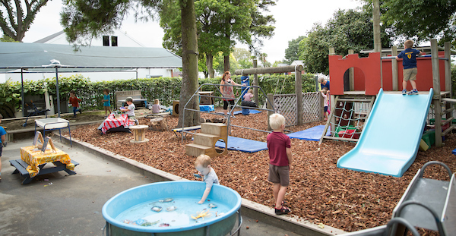

Operating Hours and 20 Hours ECE

The Pre-school implements the 20 hours ECE to children aged three years and over enrolled in the centre.

An information pack on this scheme is available from the Pre-school, which outlines the centre’s and parents’ obligations for enrolling children under the 20 hours ECE. Parents/whānau are required to complete specific documentation, including attestation agreements and any medical requirements.

Optional charge for the 20 hours ECE scheme

The optional charges may relate to aspects of education and care that are over and above regulatory standards. Optional charges enable this. Currently at Rangi Ruru Pre-school, the optional charge for children enrolled under the 20 hours ECE scheme relates to our commitment to retain the employment of 100% qualified early childhood teachers. The optional charge is $1.35 per hour capped to usage of 20 Hours ECE scheme.

Centre hours
8.00 am – 5.30 pm (Monday to Friday)
Children are enrolled for a minimum of 12 hours per week, with not less than 4 hours on any one day. Any variations to these hours are made in negotiation with the Centre Manager. The centre does not provide education and care on a casual basis.

Statutory holidays and closure over December/January
The centre is closed for statutory holidays and fees are not charged: Waitangi, ANZAC, Easter Friday & Monday, Queen’s Birthday, Labour Day and Show Day (Canterbury Anniversary).
Fees are not charged, nor holiday allowance required, for the close-down period over Christmas/New Year.
The centre still operates during the primary school term breaks (i.e. end of Terms 1, 2 and 3).
The centre closes prior to Christmas each year and re-opens early in January the following year (no fees are charged during this time). Dates are advised, in advance, each year.

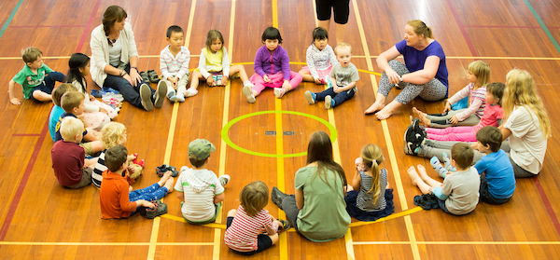

Starting at Rangi Ruru Pre-school

Families, whānau and caregivers are always welcome to visit the centre prior to enrolment. Please phone or email first so an appropriate time for a visit can be arranged.
In order to make the transition to the centre as smooth as possible, we invite you to stay with your child for as long as it takes to settle. We advise you to return earlier on the first day or days, as it may take time for your child to adjust to the environment.
When your child starts you are asked to provide/complete the following forms:
- ‘About Me’ form.
- Excursion form on the back of the enrolment form.
- Publicity and Marketing consent.
- Birth Certificate/Passport
- Immunisation Records
- Medical information/consents
Children are welcome to bring any special toys or items that will help them to settle.
Your child’s art work will be stored in the slots in the foyer area for you to collect.

What to bring
You are asked to bring a piece of fruit (to be shared) for morning or afternoon tea. Children are welcome to bring a named drink bottle.
However, water is always available. Please provide a packed lunch in a named lunch box if your child is booked for the lunch hour.

Note: The Pre-school is a nut free zone and for health and safety reasons we ask that peanuts, including peanut butter are excluded from children’s lunch boxes.

Please ensure you have advised the staff if your child has any allergies/food intolerances.

The following items are a guide of what to bring:
- Several changes of clothes (clearly named)
- A hat and sun screen (in summer).Spare hats are available
- Warm clothes for the outdoors (in colder weather)
- A piece of fruit which is shared at morning and afternoon tea time
- Disposable nappies and wipes (if required).

Arrival procedures

On arrival, please hang your child’s bag on hooks or place in a locker. If your child is in nappies, then use the hooks underneath the teacher profile board to hang their bag. Fruit may be left in the fruit bowl in the hall.

Attendance sign-in for your child:
This is situated in the foyer and children’s names are listed alphabetically. Children can place their names on the children’s ‘arrival’ board.
Parents/whānau/caregivers must record the arrival and departure times each day and sign the roll to confirm their child’s attendance.
Enter the arrival time on the attendance roll next to your child’s name and your signature. You must repeat this process on departure.
This information is important as it is used in the event of an emergency, as well as documentation required by the Ministry of Education.
Any changes to your child’s session times must be discussed with Linda, our Centre Manager.

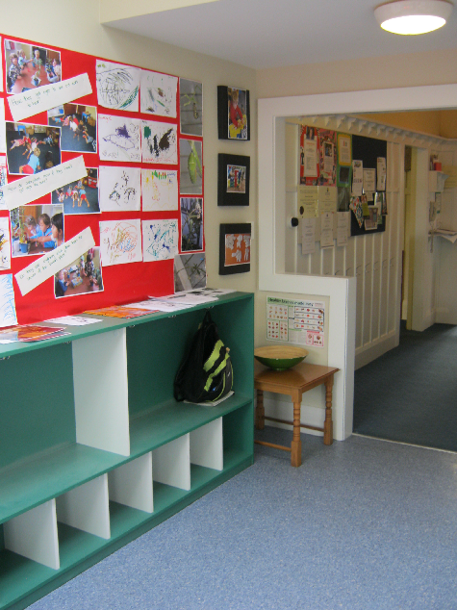

Our entranceway

Health and Wellbeing

Immunisation register
A register containing details of each child’s immunisation record is required for Crown Health notification. The register may be used to identify children who are not immunised during an outbreak. Information is confidential. The child’s immunisation certificate must be sighted and details recorded. You are asked to update this record as required.

Vision and Hearing tests
Staff from the Canterbury District Health Board come in to the centre to check the vision and hearing of children aged 4 years as part of the b4 5 check. (www.cdhb.govt.nz)

Illness
The centre’s Health/Sickness policy applies to all children enrolled at the Pre-school.
Please note that children cannot attend if they have a cold (yellow/green discharge), sores, discharging eyes (conjunctivitis), rash, fever (within 24 hours of symptoms) or diarrhoea/vomiting within the past 48 hours.
The Senior Teacher/Person Responsible has the right to refuse a child who is obviously infectious. Parents/whānau/caregivers are asked to notify the staff if a child has been exposed to a contagious illness or if they have contacted head lice.

Accidents
All accidents of a significant nature and/or requiring medical attention are recorded in an accident register and parents/whānau/caregivers are notified. Serious accidents require an in-depth report and are advised through the Service Provider nominee to the Principal, Rangi Ruru Girls’ School. Incidents not requiring attention may also be recorded, if of a significant nature.

Administering medication
If your child is to be administered first aid or medication by staff, this information is recorded on the ‘About Me’ form. A register is used to record details of all medication (prescription medication only should be administered) given to children while attending the centre. Parental consent is required and recording of medications administered ensures the practice is systematic and authorised.

Crisis Management procedures
The centre follows to the school’s crisis management procedures for any emergencies. Evacuation plans and meeting points are displayed in the Pre-school and a copy of the emergency procedures are in the policy folder. In the event of an emergency all parents/caregivers are contacted via text messaging/phone calls.

Keeping you Informed and Involved

Parents/whānau/caregivers are acknowledged as first teachers and staff work collaboratively with you in the interests of your child. You are most welcome to share in your child’s Pre-school experience, whether it be spending time in the centre or assisting with excursions. Parental involvement in fund raising is not a necessity, with the exception of raffles or other projects initiated by the Parents’ Advisory Group.

Communicating with families
Rangi Ruru Pre-school aims to communicate with families in an open and responsive manner. Weekly emails are sent home telling parents about what has been happening for children during the week.

Daily and weekly information and Newsletters
Please ensure you check the daily noticeboard for information. As appropriate, individual notices are sent home with children or alternatively mailed.
Weekly e-mails are sent to families, reviewing the week’s events and a fortnightly newsletter is distributed with additional information, including up-coming events and key dates.

Website News Posts
We regularly post updates and photos of centre experiences on our website, under our About Us, News section. We love celebrating the depth and complexity of learning that occurs within our centre.

Children’s profile books
Your child will be provided with a profile book, which is a documentation of the child’s learning experiences at the Pre-school. A teacher is responsible for documenting learning stories about your child’s experiences, interests and achievements at the centre, and parents/caregivers have opportunities to add a ‘parents’ voice’.
Your child will enjoy sharing the portfolio with you, and you are welcome to share this either in the centre or to take it home.
The portfolios are updated at least once a term, depending on the number of sessions your child attends.

Parent Advisory Group
Our Parents’ & Whanau are invited to participate in Parents’ Advisory Group meetings, which occur at least once per term. We enjoy having our families participate and support the staff in any social, educational or fund raising events when necessary. Families are not committed to ‘joining’ the group, rather this is a forum where parents can attend when and if they are able.

Parent Information folder - policies and procedures
A parent information folder is on the bulletin board, and contains information on our policies and procedures, the latest Education Review Office report and Early Childhood (Centres) regulations.

The following policies/procedures are in the folder for your information:

Administration of Medicines Allergy Register procedure
Social Competence Care and Protection of Children
Children with Special Needs Code of Ethics for Registered Teachers
Communicable Diseases Complaints
Complaints Against a Staff Member Crisis and Emergency Management Procedures
Enrolment Excursions
Fees Harassment and Bullying
Hand washing Health and Safety
Resting and Sleeping Children Parents’ Advisory Committee
Parent Education Poisonous Plants
Premises and Equipment Illness and Immunisation
Non-Smoking Workplace Sun Protection
Food Provision Supervision plan
Transition to School Te Tiriti o Waitangi
Visitors’ Procedure.

Communication and Complaints Procedure

The lines of communication for complaints are displayed on the parent noticeboard in the entrance foyer.
If you have any queries or concerns you are encouraged to talk to the Centre Manager/Person Responsible in the first instance and, if necessary, the matter may be referred to the licensee.
All complaints in writing will receive a written reply.

Fees and Accounts

Enrolment is inclusive of State school term breaks and Public Holidays. Fees are paid by direct debit on a monthly basis. Fees are not charged for statutory holidays. Bookings are reconfirmed on a yearly basis but can be amended, with notice, as required by families.

The fees are $8.10 per hour or part thereof (from 1st May 2017)

Discounts and subsidies
‘Full week’ (i.e. Monday to Friday 8.00-5pm) attendance discount – 10% of fees.
Sibling discount of 10% of fees for those enrolled at the same time.

Introduce a friend:
A friends and family credit, of up to $100 is offered to families who are directly responsible for an enrolment.

Old Girls:
A friends and family credit, of up to $100 is offered to families who have been previous students of Rangi Ruru Girls’ School.

Early arrival/late fee:
An early/late fee of $10.00 per 10 minutes is charged on a pro rata basis, outside of the child’s normal enrolled hours.

Accounts
All accounts are managed through the Rangi Ruru Girls’ School Business Manager’s office and the centre’s staff do not handle invoices or receipts.

Any fees matters should be discussed with the Business Manager’s Office –
Tel: Angela Hirst 983-3746 or a.hirst@rangiruru.ac.nz.

Childcare subsidy/WINZ
Children who attend a licensed early childhood service for at least three hours a week can, under certain criteria access subsidies.
Contact: www.workingforfamilies.govt.nz

Notification of withdrawals
For children who withdraw during the term the parent/caregiver must give three weeks’ notice in writing and fees are paid or payment in lieu thereof.

Changing session times
Two weeks’ notice is required in writing to change session hours/times. This ensures accurate documentation and also assists with planning for roll numbers.

The following applies to absences:

Absences
The centre does not offer casual education and care; therefore, if a child is absent the place is not able to be filled by another enrolment. The centre cannot claim funding for child absences that continue into a fourth week and beyond.

If a child is absent for more than 21 days without a written explanation, the child is withdrawn from the roll. Fees are charged for sick days, but, if the sickness is of a long duration, then in such special circumstances the fees may be reduced by 50%.

Children not enrolled under 20 hours ECE

Each child will be entitled to a yearly prorate holiday allowance of up to four weeks’ normal attendance. This will be charged to the family at a 50% discounted rate.

Children enrolled under 20 hours ECE

No fee paid for up to 3 weeks’ absence, under 20 hours ECE. The optional charge continues during this absence. Retaining fee of 50% of the normal hourly fee of $8.10 (i.e. $4.05 per enrolled hour) is charged for continued absence after the first three weeks.

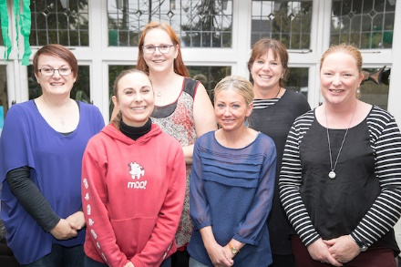

Our team

